Broadway On Demand Purchase & Viewing Instructions
for a Live Event

PURCHASING YOUR STREAM

STEP 1: Locate the production you want to purchase

CLICK THIS LINK to be taken directly to the event show page. It should look something like this:

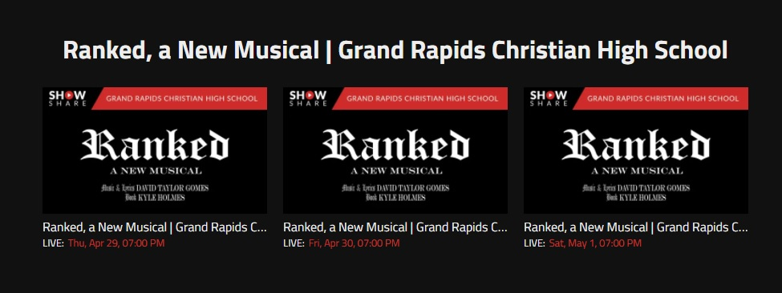

STEP 2: Select the Performance

Click on the performance you would like to view, and you should see a new page that looks something like this:

Step 3: Click the Purchase Now! button

Click the “PURCHASE NOW!* at the bottom of the page.

*note that the Purchase Now! button won’t appear if you have already paid for the event or the event is free of charge

STEP 4: Log in /Create an Account

If you haven’t done so already, you will be prompted to either log in or create an account.

If you already have a Broadway On Demand account, enter your email and password in the given fields.

If you don’t already have a Broadway On Demand account, select “Click here to Sign Up” and enter an email and password.

STEP 5: Pay for Your Stream
Once you’ve logged in or created your account, you will be automatically taken to the payment page.

Here you can pay for the stream with a credit card or PayPal.

If you’ve been given a Promo code, enter the code into the “Add Promo Code” field and click apply.

Confirm your purchase to complete the transaction.

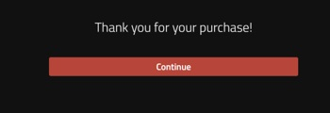

Congratulations! You’ve completed your purchase and now are ready for the show!

WATCHING THE SHOW

STEP 1: Navigate to the Production Show Page

CLICK THIS LINK to be taken directly to the event show page. (Hint: this is the same link you clicked to purchase the event)

If you haven’t done so already, you will be prompted to log in to your account. Once logged in, if you’ve arrived prior to the start time, you will see the event countdown page (picture 1). If the event has started, you will see the production on this page (picture 2)!

Picture 1:

Picture 2:
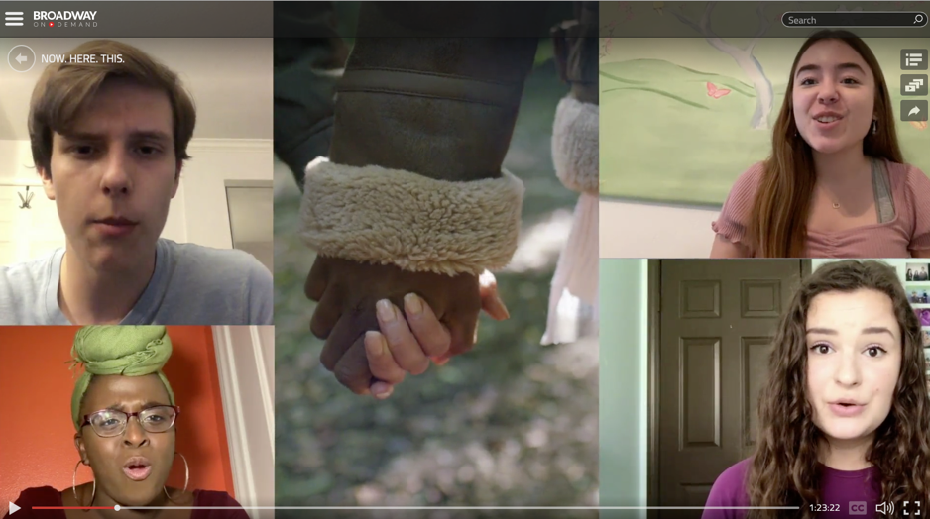

Enjoy the show!

If you experience any difficulties trying to purchase or access the production, please email info@broadwayondemand.com.

